Small use case:

Search for HTML:

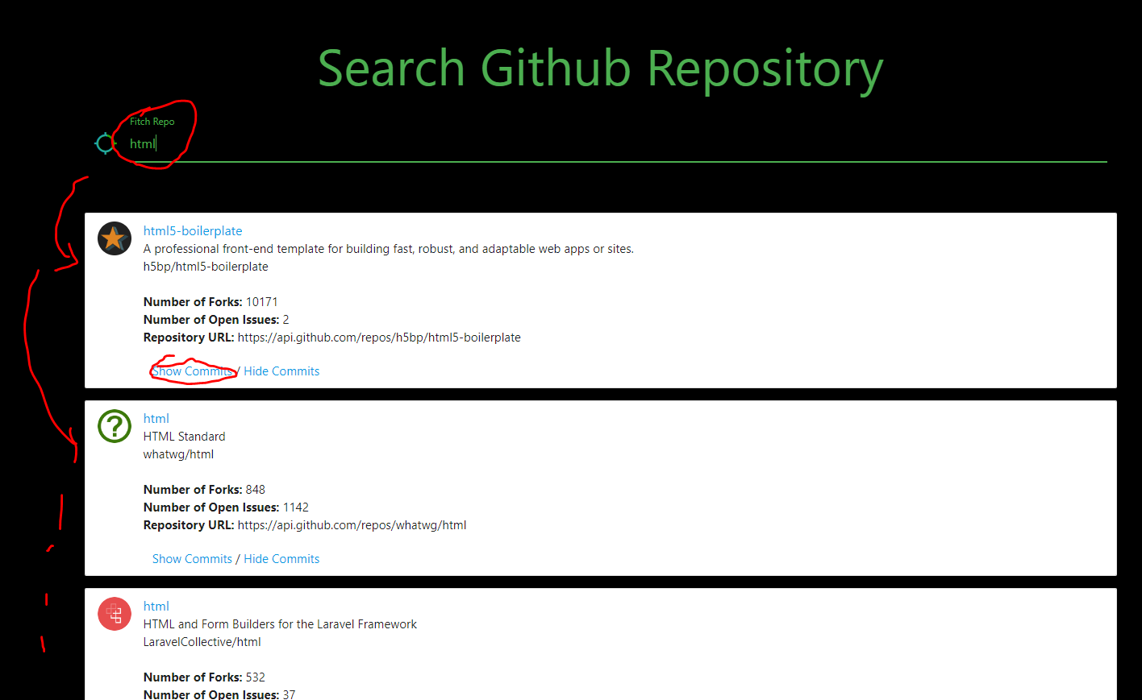

Show Commits for the first repository:

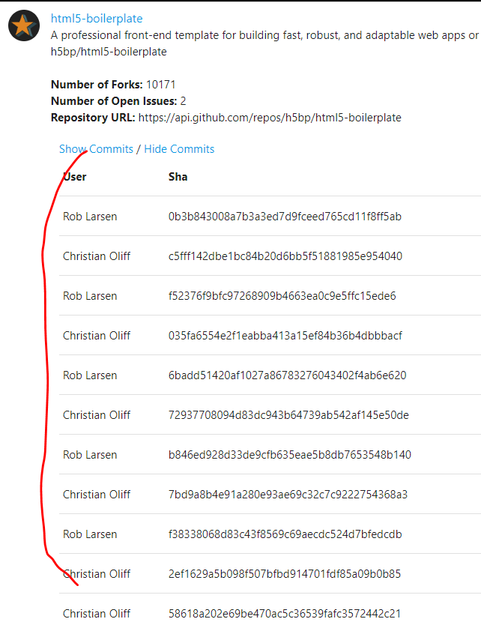

Pagination was not actually done but could be added quite simple.

The results per page is a parameter set at the github.js file, repo_count value. Currently, this value is 4.